SNAPSHOT OF THE SHORELINE FOR WATER QUALITY 2012
Lac Bernard, Quebec, Canada
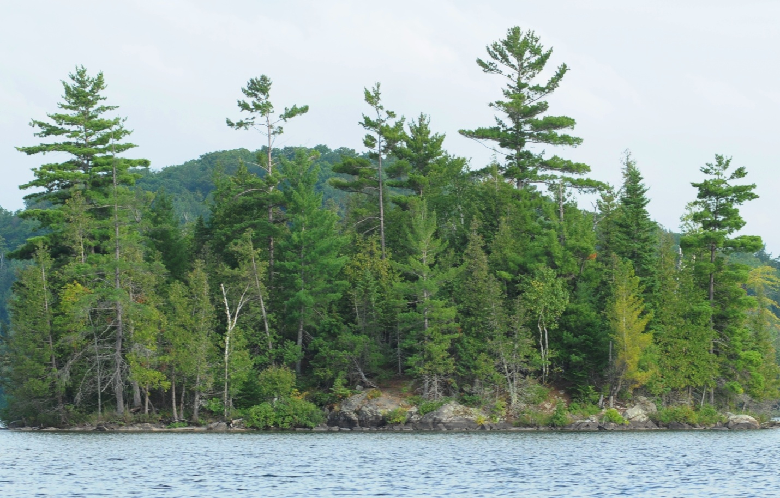
The Owners’ and Residents’ Association of Lac Bernard
By Christine McClelland
September 1, 2012

Introduction
Shoreline vegetation and structural alteration as well as boat traffic put ecological pressure on Lac Bernard. These factors affect the lake’s natural shoreline; decreasing its ability to support native species, inhibit erosion and moderate the influx of nutrients to the lake.
Shoreline vegetation is important because it reduces erosion, filters surface water runoff therefore reducing nutrient and toxin contamination and provides a cool climate for animal habitat, foraging and breeding grounds. Shoreline stabilization with retaining walls severely decreases ecological function and in some cases, increases erosion in surrounding areas due to wave reflection. They provide no barrier to surface water runoff and destroy habitat. Boat traffic increases with every year as does the size of the boats and the waves they create. Large waves that reach shore can erode the shoreline and harm the animals and plants that inhabit the first few feet from the waters’ edge.
Shoreline alteration and boat use are manageable factors in the protection of the lake’s ecological health. Reducing anthropological impact on the riparian zone ensures that native animals have the right conditions to reproduce, native plants can control natural erosion, and water quality is optimized.
This report will describe the current state of Lac Bernard with respect to shoreline alteration. In addition, specific detail will be given about evidence of beaver activity, erosion, aquatic plant masses and presence of invasive species. The goal of this project is to describe the whole shoreline of Lac Bernard as it is in the summer of 2012 to provide a baseline against which future ecological assessments can be made.

Method and materials
Shoreline photographs were taken approximately 120 m from shore using a Nikon D300 with a Nikon ED AF Nikkor 80-200mm lens and a GP-1 GPS unit with an accuracy of 10 m horizontally. The distance from shore was determined using a Bushnell Laser Range Finder Yardage Pro 1000 which has an accuracy of 3 m. When it was not possible to maintain the standard distance from shore, as was the case in small bays or near navigational hazards, the camera’s focal length was altered to maintain a standard field of view. If the field of view was not close enough to the standard size, the photographs were magnified or minimized during analysis to accurately represent the portions of each shoreline state. The categories of shoreline used were as follows:
1 – Completely intact up to and beyond 15m from the shoreline, no disturbance
1A – Rocky substrate with naturally sparse vegetation
1B – Thick substrate, dense vegetation
1C – Low-lying, wet, dense vegetation
2 – First 5m of shoreline intact, varying degrees of disturbance from 5-15m
2A – Largely undisturbed, dense vegetation, high integrity
2B – Approximately half vegetation removed, human use evident
2C – Most to all vegetation removed, high human activity
2D – Undisturbed up to dwelling
3 – First 5m of shoreline disturbed
3A – All trees removed, dense low vegetation
3B – Narrow strip of native vegetation
3C – Vegetation removed, no reinforcement
3D – Dwelling such as shed, cottage, house, boathouse, large deck, etc.
3E – Reinforced with riprap
3F – Reinforced with retaining wall
A scale with a minimum unit of 5 percent was applied to each photograph. Figure 1 demonstrates the categorization method.
Figure 1. Examples of shoreline categorization.
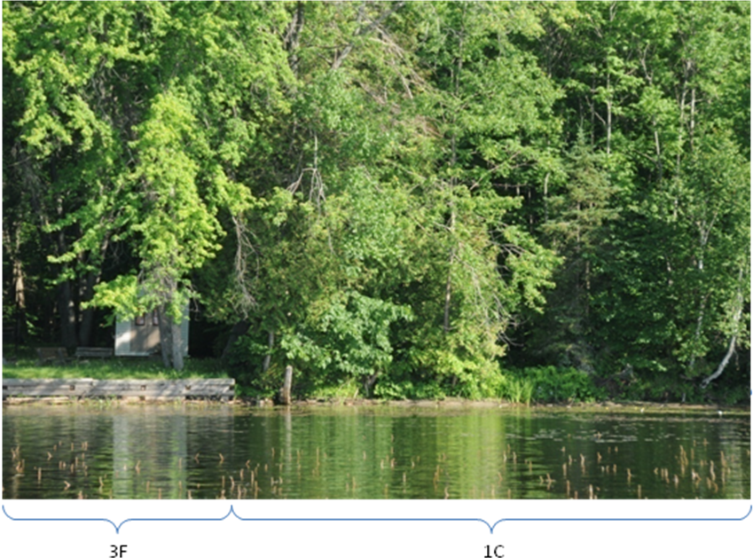
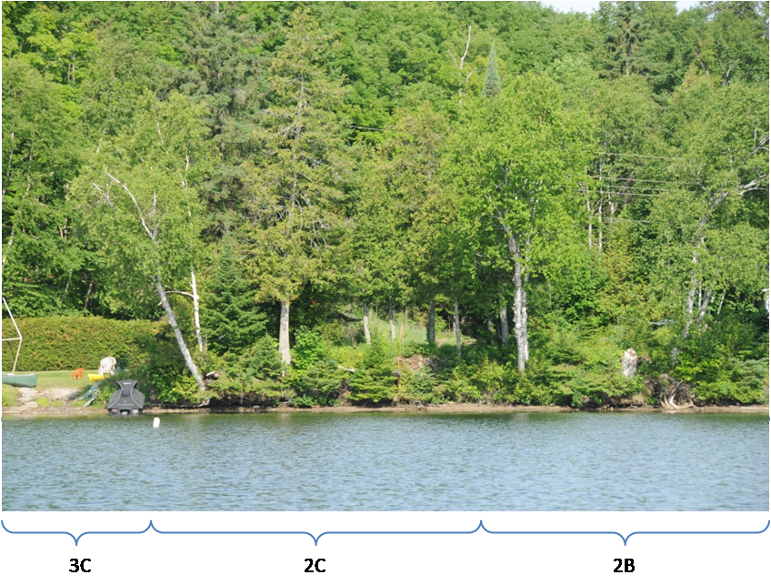

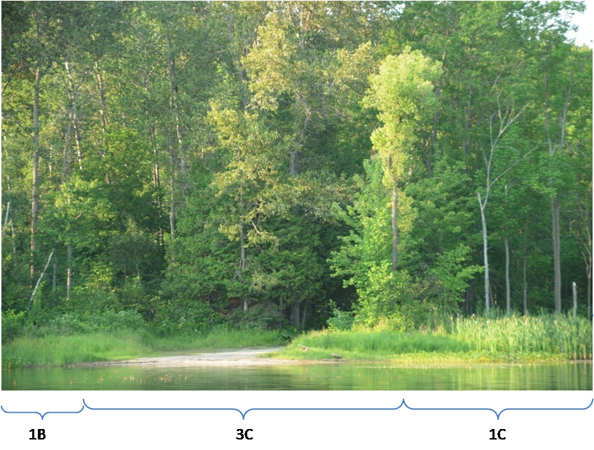
Photographs were taken so as to minimize overlap. The overlapped portion was not included in the tally of percentage of each category of shoreline represented in the photograph (Figure 2).
Figure 2. Example of overlapping photographs and uncounted portion.
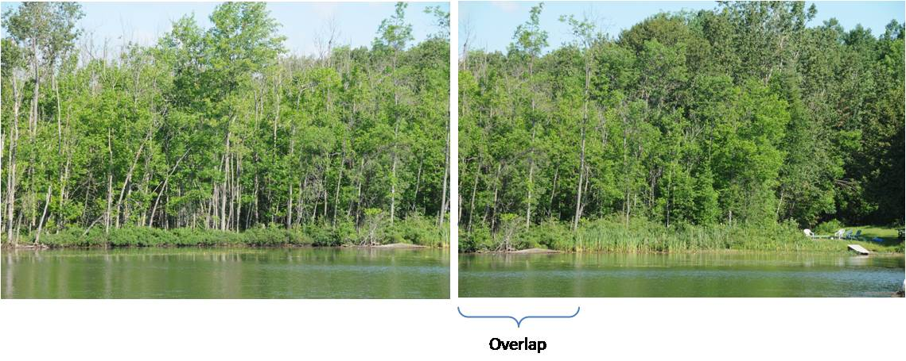
All of the islands on the lake were also photographed with geoposition information but without being a standard distance from shore. The photographs were not analysed, rather their purpose was to log the general state of the island shoreline as it was in 2012 for future comparisons. With few exceptions, the shorelines of the islands were completely undisturbed.
While taking the shoreline photographs, areas of dense aquatic plants were noted. Photographs and specimens were collected in the case of the milfoil, for further identification purposes. General observations were also made to detect the presence of any other invasive species. Beaver activity and lodges were also noted, along with evidence of erosion. The locations of dense aquatic plants, beavers and erosion were noted on the map but not associated with specific GPS coordinates.

Observations, analysis and commentary
Shoreline categorization
Of the 1101 shoreline photographs taken, 1076 were analysed for shoreline status. The 25 remaining photographs were not counted because the shoreline captured was completely overlapped by preceding or following photographs. In most cases, the redundant photographs were used to better categorize the shoreline status of the counted photographs. The status of the islands was not counted in the analysis because they would have biased the results towards the undisturbed category. The total percentages for intact, partially altered and completely altered shoreline were 48.3, 11.2 and 40.5, respectively (Table 1). Figure 3 shows the proportions of the subcategories.

Table 1. Percentages for each category of shoreline development.
Category | Description | Total %
1 | Full 15 m undisturbed | 48.3
2 | First 5 m undisturbed then varying disturbance | 11.5
3 | First 5m of shoreline disturbed | 40.2

Figure 3. Percentages for each subcategory of shoreline development.
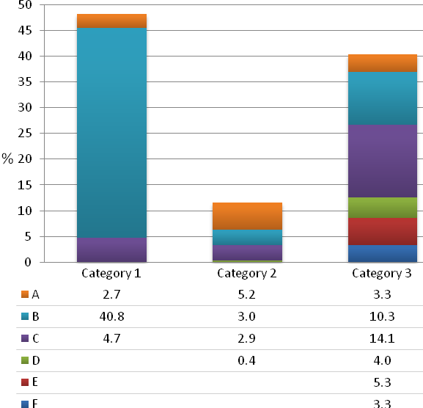
Due to the difficulty in estimating distances, some small inaccuracies in categorization were inevitable. However, the crucial categories of intact and completely disturbed shorelines were easily observed so the overall effect of any minor categorization imprecision was minimal. Photograph properties included GPS locations for nearly every photograph. Given the fact that photographs preceding and following contain location information and that photographs were taken in sequence around the shoreline of the lake, the locations of the photographs missing positioning data should be easily determined for future comparative purposes. Photographs were archived on an external hard drive along with a file indicating on a map the approximate location of every 25th photograph. Figure 4 gives an overview of the average level of disturbance around the lake.
Figure 4. Approximation of shoreline status for Lac Bernard.
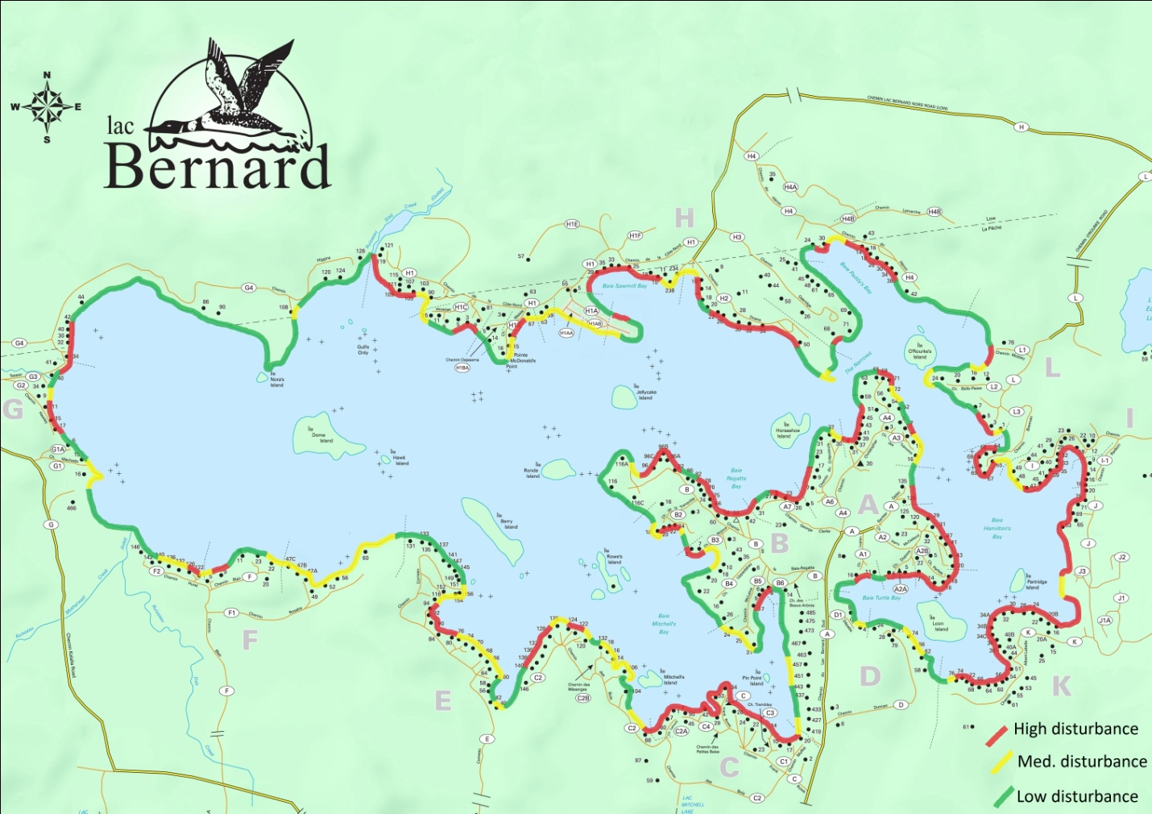

Inlet and outlet
The inlet and outlet of the lake were explored late in the summer once the water levels increased, making the waterways passable in an aluminum boat. The main inlet consists of the convergence of the Motherwell and Fish creeks. The entrance to the inlet is a series of very shallow water paths through dense aquatic plants namely, pickerel weed, various water lily species and Eurasian milfoil. These paths are littered with wood chips, evidence of the high beaver activity. From the mouth of the inlet, a distance of approximately 150 m was navigable until a series of dams obstructed the waterway. There was evidence that the dams had been broken by humans, both recently and repeatedly in the past: gaps in the current dams (which were being repaired by the beavers), debris pulled out of the water to the sides of the dams and logs sawn in half. The channel was on average 8-10 m wide with a mildly sinuous deeper channel, maintained by both the current and beavers. Shallow pools provided habitat for tadpoles, frogs, painted turtles and minnows. The vegetation was dense and diverse. Wetland species such as Sweet gale, Virginia creeper and various grasses dominated the riparian zone with somewhat rarer plant species such as the cardinal and turtlehead flower also observed (Figure 5).
Figure 5. The Cardinal (left) and Turtlehead (right) flowers observed in the inlet to Lac Bernard.
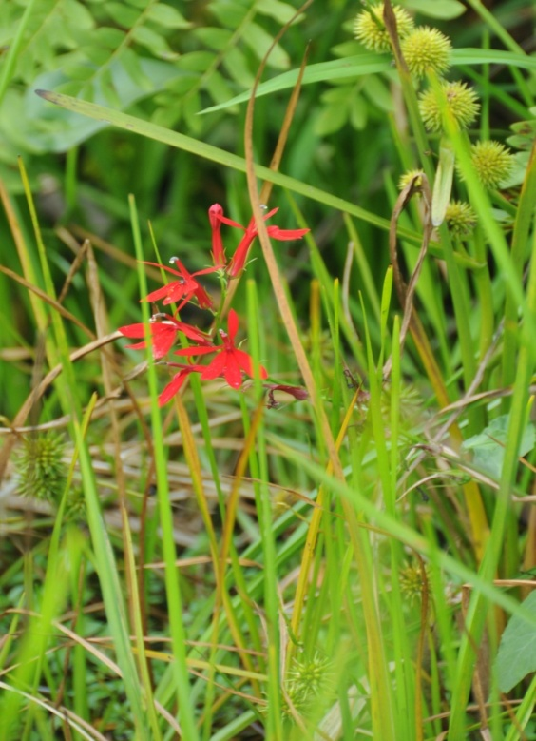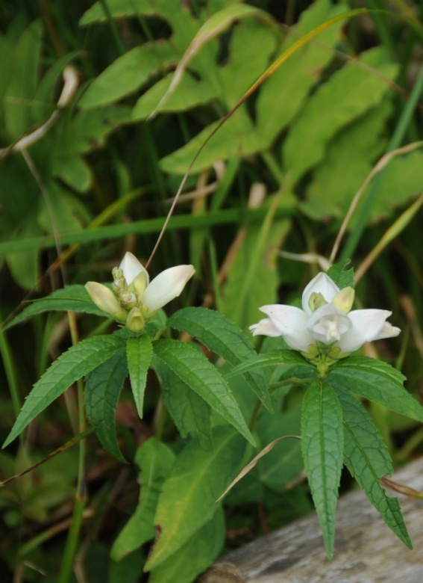
The outlet, Stag creek, was completely impassable beyond the pool linking the lake with the creek. At low water levels, entrance to the pool from the lake would also be difficult due to rocks and woody debris. The shoreline of the pool was completely undisturbed save for a small section that had been cleared near the mouth of the creek which was strewn with garbage and abandoned household items. Uprooted aquatic plant masses accumulated at the entrance to the pool from the lake (Figure 6). The pool had numerous masses of Eurasian milfoil and the bottom was covered in low-growing Canada waterweed (Figure 7).
Figure 6. Uprooted aquatic plant masses at the outlet of Lac Bernard.
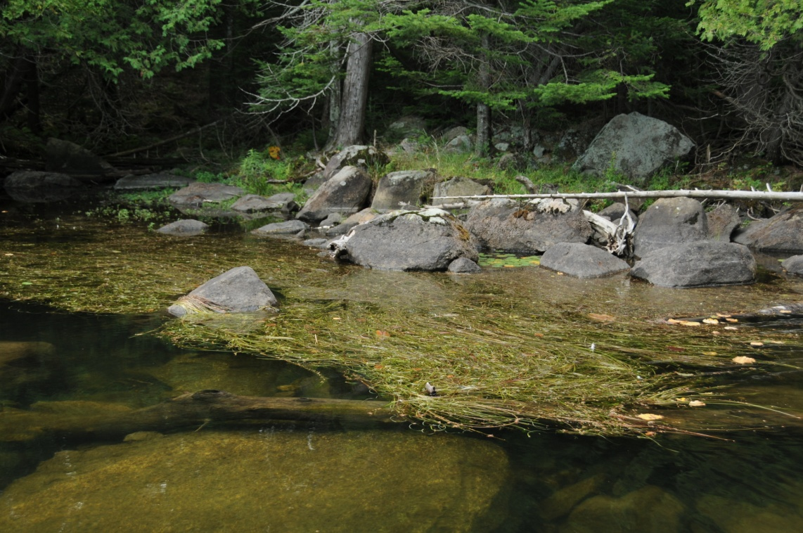
Figure 7. Eurasian milfoil in the pool before the outlet of Lac Bernard
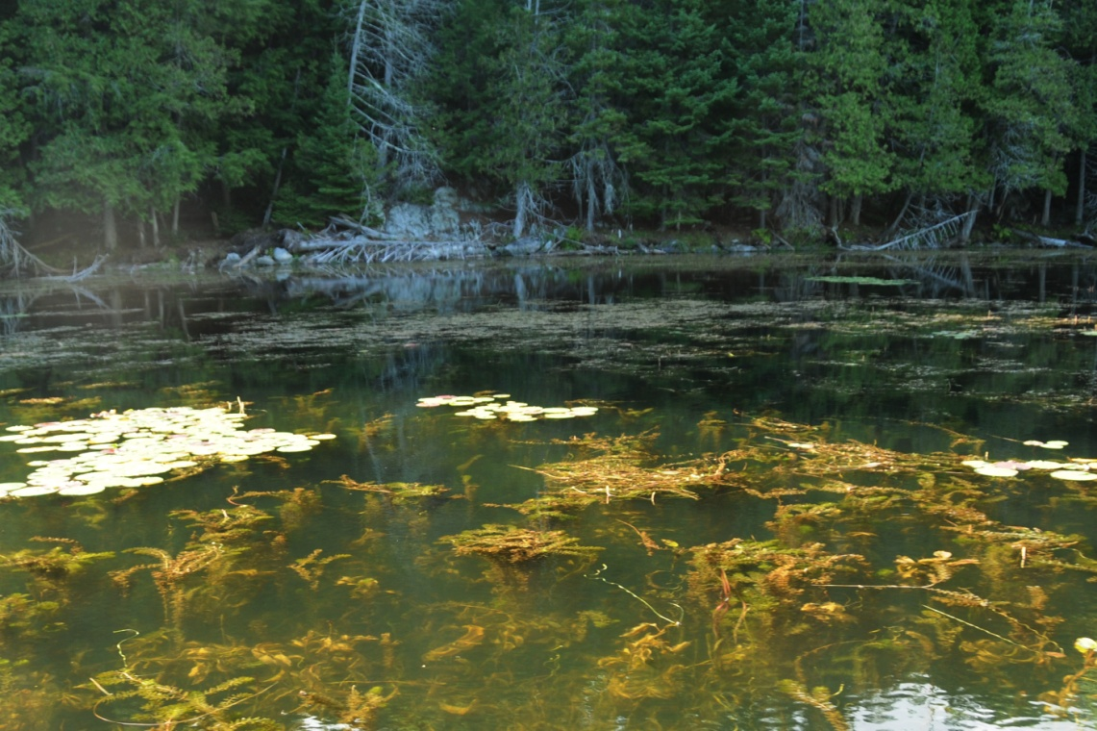
Stag creek is impassable due to a combination of boulders and a number of large beaver dams. Recent beaver activity was limited to the first small dam which was constructed of small branches, some still with leaves. The second dam was much more than a dam due to the debris that has collected thereupon over many years. Some of the logs in the piles of debris are 40+ cm in diameter. Other debris includes a folding chair and whole sections of dock.

Beaver activity
Numerous beavers were observed while the shoreline photographs were being taken, however, relatively few beaver-felled trees were observed. The inlets and outlet had dams impeding water flow and nine lodges were found throughout the rest of the lake (Figure 8). It is difficult to assess whether the lodges were fully active or abandoned because much of the restoration of beaver lodges happens in the fall in preparation for winter therefore only the locations of the lodges were observed not their activity status.
Figure 8. Locations of beaver lodges and dams on Lac Bernard.
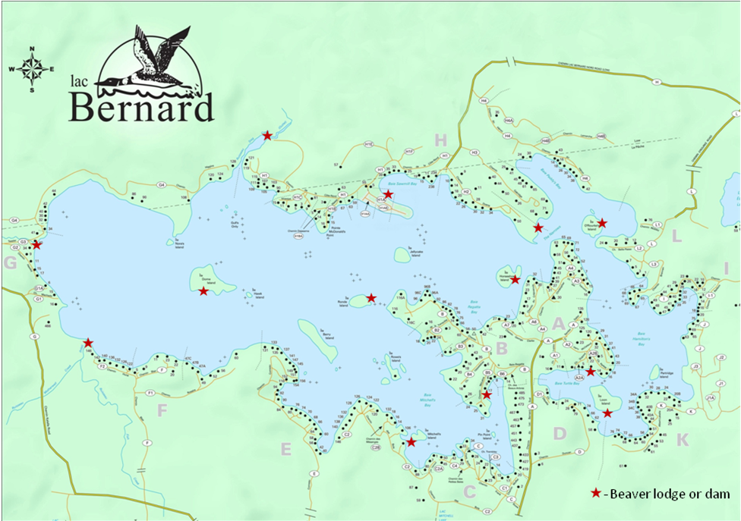

Aquatic plants
There were eleven areas found on the lake that had dense aquatic plant growth. While it is difficult to define the exact extents of these areas, Figure 9 shows the locations and approximate shape and size of the plant masses. For the most part, milfoil dominated the masses though there was extensive growth of waterweed in the bay before the Stag Creek outlet.
Figure 9. Locations of dense aquatic plant zones at Lac Bernard.
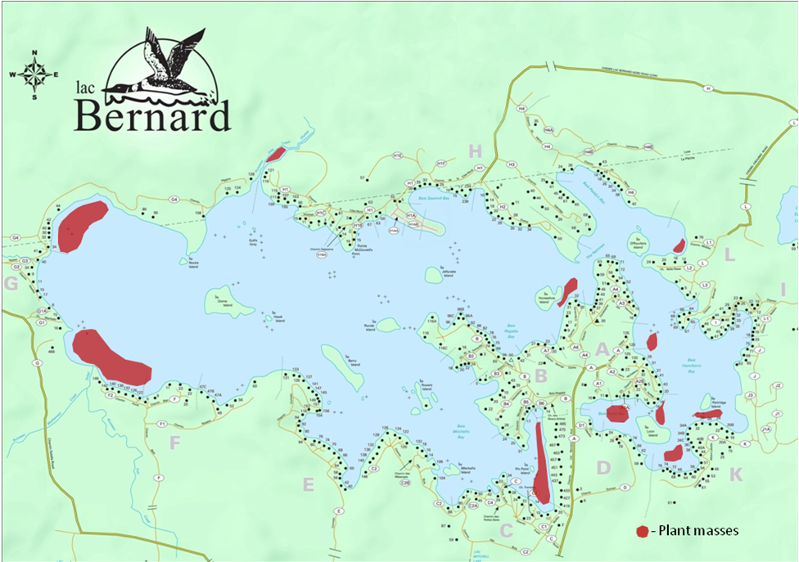

Erosion zones
Figure 10 illustrates the few areas around the lake showing obvious erosion. The area called “The Narrows”, joining the two large sections of the lake, displayed definite signs of erosion: areas of exposed soil and tree roots, receding shoreline and slumping/overturned trees. Boat traffic at The Narrows is very high and the waves hitting the shoreline have little open water to dissipate their size, thus the wave action at The Narrows is of particular concern. Minimal natural erosion should be expected at The Narrows given the prevailing wind at various times of the year and the catchment area however, it would not account for the severity of the erosion observed. Dome Island also showed a small area of significant erosion, the cause of which is likely natural.
There were three areas that had high percentages of riprap and retaining wall reinforcement (Figure 10). The increased incidence of artificial reinforcement is often an indicator of erosion as cottagers add substrate to mitigate the loss of shoreline. It is suspected that these areas would also show signs of erosion had the shoreline not been reinforced.
Narrow passages, also shown on Figure 10, are at risk for erosion due to wave action and should be monitored to ensure the stability of the shoreline.
Figure 10. Location of erosion zones and narrow passages at Lac Bernard.
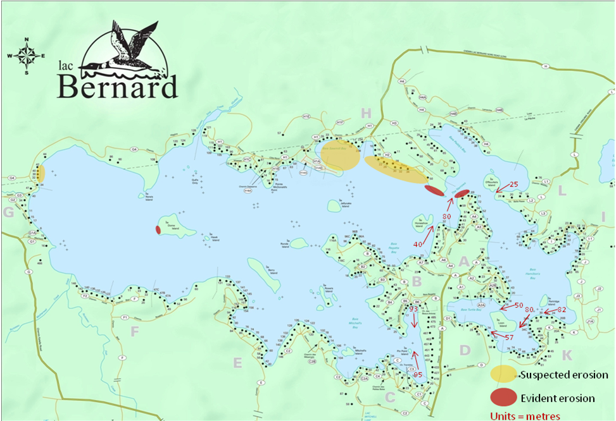

Invasive species
Using the State of Connecticut’s Invasive Aquatic and Wetland Plants Identification Guide along with photographs of specimens from their online herbarium, and in collaboration with aquatic ecologist Paul Hamilton (Canadian Museum of Nature), the milfoil specimens collected at Lac Bernard were identified as the Eurasian variety (Figure 11). The specimens collected on Lac Bernard had the characteristic Eurasian milfoil morphology, specifically:
Feathery leaves, less than 5 cm long, with 14-24 leaflets on either side of the axis
3-6 leaves arranged in whorls around the stem
Flowers on an emergent spike up to 20 cm above water, 4 flowers/whorl
Figure 11. Eurasian milfoil collected at Lac Bernard.
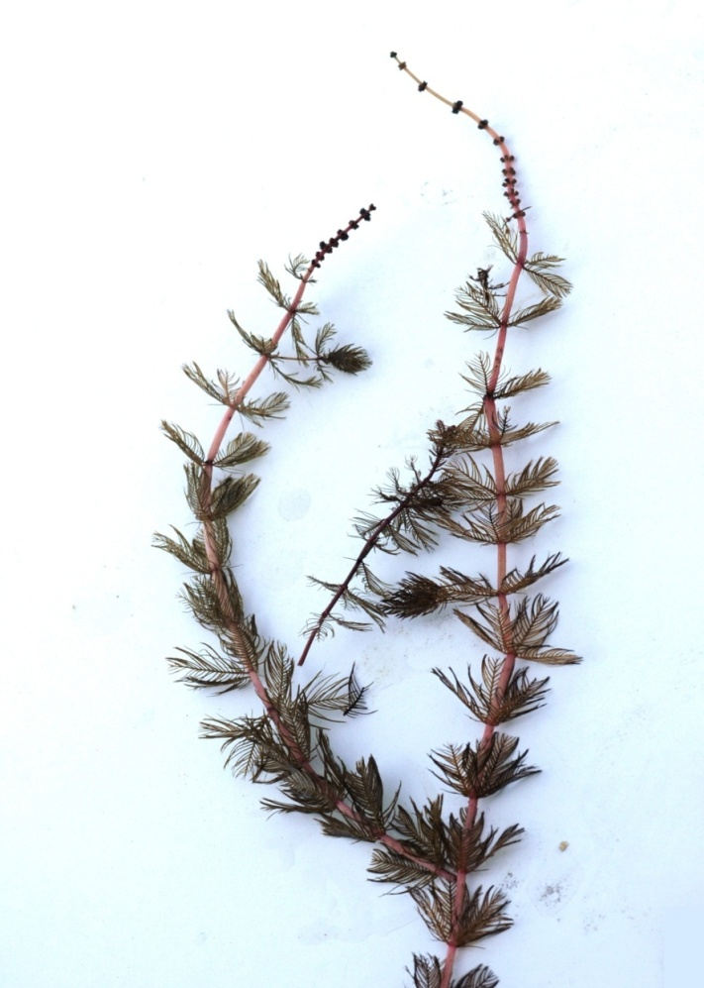
Purple loosestrife was also found in numerous locations. No zebra mussels were observed.

Conclusion
The overall health of the lake is fairly good. Anthropogenic shoreline alteration, erosion and the presence of Eurasian milfoil should be addressed in order to assist in the conservation of the lake’s ecological integrity.
Approximately half of the shoreline is undisturbed and many property owners have taken steps to naturalize their shoreline. Yet in general, where there is a cottage there is shoreline degradation. It is natural to want a view of the lake, an area to access the lake and park watercraft. To maintain the quality of the cottagers’ experience at the lake, however, the lake must be healthy and safe for recreation. Changes such as smaller docks, adding native plants along the shoreline and the removal of hard shoreline reinforcement would increase the ability of the shoreline to perform the processes that contribute to the health of the lake.
A major threat to the natural shoreline of Lac Bernard is erosion and the actions that cottagers take to prevent it. There are numerous properties that have artificial reinforcement of the shoreline, specifically riprap, to prevent erosion. Erosion should be controlled with soft-shore protection, leading to the naturalization of the shoreline with vegetation and natural debris. Reinforcement with riprap and retaining walls severely decreases the ecological integrity of the shoreline and should be avoided. The erosion observed at The Narrows could be minimized with efforts to decrease the size of the waves hitting the shoreline. This can be achieved by floating log booms or by designating the area a “No Wake” zone.
Boat traffic is also a concern due to the presence of Eurasian milfoil which can propagate itself from tiny fragments created by boat traffic. This invasive variety of milfoil can form extremely dense masses which can interfere with recreational activities, impede water flow at the inlet and outlet, increase localized sedimentation rates and decrease floral and faunal biodiversity. A lake-wide approach to decrease the speed and amount of boat traffic in established milfoil masses is crucial in managing the spread of the Eurasian milfoil.
Educating the cottagers as to why these issues are important for the lake to remain a place of recreation and relaxation is an integral step in protecting the health of the lake. Cottagers must consciously make decisions that will help the ecology of the lake. Shoreline integrity must be protected and watercraft, particularly boats that produce large waves, must be operated in an ecologically responsible manner. Small considerations now can greatly improve the health of the lake for years to come.

Online Resources

Shoreline ecology
Ministère du Développement durable, de l’Environnement et des Parcs du Québec
http://www.mddep.gouv.qc.ca/eau/rives/richesse/index-en.htm
Department of Fisheries and Oceans, Government of Canada
http://www.pac.dfo-mpo.gc.ca/habitat/reveg/index-eng.htm\
US Environmental Protection Agency
http://water.epa.gov/type/lakes/shoreland.cfm
State of Minnesota, Department of Natural Resources, Division of Fisheries
http://files.dnr.state.mn.us/assistance/backyard/shorelandmgmt/savewateredge.pdf

Wetlands
Ministry of Natural Resources of Ontario
http://www.mnr.gov.on.ca/en/Business/Biodiversity/2ColumnSubPage/STDPROD_070619.html
Hinterlands Who’s Who
http://www.hww.ca/en/where-they-live/wetlands.html

Milfoil
State of Washington, Department of Ecology
http://www.ecy.wa.gov/programs/wq/plants/weeds/milfoil.html
State of Connecticut Invasive Aquatic Plant Program
http://www.ct.gov/caes/cwp/view.asp?a=2799&Q=459890&caesNav=|
US National Park Service
http://www.nps.gov/plants/alien/pubs/midatlantic/mysp.htm

Beavers
Hinterland Who’s Who
http://www.hww.ca/en/species/mammals/beaver.html

Erosion
Ministry of Natural Resources of Ontario
http://www.mnr.gov.on.ca/en/Business/Water/2ColumnSubPage/STEL02_165454.html
Ministry of Natural Resources of Ontario via link from Gananoque Rivers Waterway Association
http://www.grwa.ca/mnr_docs/MNR%20Extension%20Notes/Shoreline%20Buffers.pdf
http://www.grwa.ca/mnr_docs/MNR%20Extension%20Notes/Preserving%20and%20Restoring%20Natural%20Shorelines.pdf
State of Vermont Agency of Natural Resources
http://www.anr.state.vt.us/dec/waterq/lakes/docs/lpseries/lp_lpseries3b.pdf

