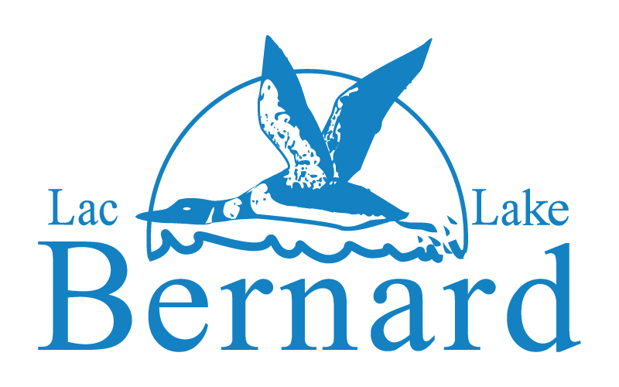

Illuminating the Past …
…for the Present
…For the Future

Lake Bernard has a rich and fascinating past. Generations of cottagers have built a legacy that has shaped the community we enjoy today. We can’t let that legacy disappear. Join us in building a recorded history of the lake that can endure the test of time and be enjoyed and appreciated both now and into the future.
Your History and Archives Committee, working in cooperation with the Web Committee, is soliciting photos and documents that can be copied into a ‘history’ database that will be made available through the Association web site. It is also launching an oral history program to record the reflections and memories of those who have been on the lake for a considerable period of time.
Details concerning how you can help are provided below.
Photos and Documents
Please send us your old photos and any documents you think might contribute to the history of the lake. You can send digital copies in any format as well as hardcopy prints. The prints will be returned after they have been scanned. Photos and documents that meet the criteria below will be included in the history database. As an incentive to dig through your archive we will copy, photo enhance (colour correction, cropping, lighting levels, etc.), and return to you photos that have been selected by the History and Archives Committee for inclusion in the history database.
Please send your digital photos to john.mcdonald@rogers.com or contact John at 819-459-2582 to work out the details for submitting hardcopy prints.
Oral Histories
Gaye Moffett, supported by Jen Lahey, a Carleton University Journalism Graduate, would like to interview property owners and others about their reflections and memories of the lake. Interviews will be conducted in either English or French using interviewers who are proficient in either or both languages. Priority will be given to those who have been on the lake for an extended period of time. The interview will be recorded on a digital micro recorder and last approximately 1 hour. In order to conduct the interviews we need to know who to interview.
Please get in touch with Gaye to either volunteer for an interview or to advise her of those she should be contacting. You can reach Gaye at gaye.moffett@gemhealthcare.com or by phone at: 819-459-1431
The Association Archivist, Charles Topp (ctopp@charlotteengineers.com), supported by the members of the History and Archives Committee, is the keeper of the records. While copies of photos, documents, and oral histories may be used for a variety of purposes (posting on the web site, responding to requests, etc.), the Association Archivist is responsible for storing and maintaining the master copies as the Archives of the Association.

Your History and Archives Committee
Alison Jones
Jen Lahey
Will Lockhart
John McDonald
Gaye Moffett
Charles Topp

