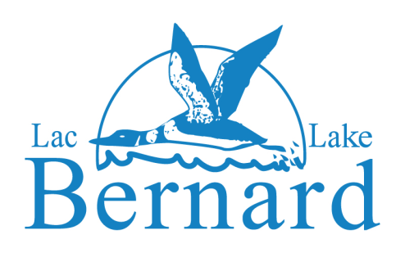

June 2018
Hello Lac Bernard Lake Owners,
Your association executive has been very active this past year and I wish to give you some highlights.
Environment: J.C. Hudon as Environment Chair still maintains his diligence for the eradication of Eurasian Milfoil campaign in our lake. We have joined a coalition with ABV des 7 and other lake associations to lobby the Quebec government to initiate and implement a national management program for Eurasian watermilfoil as early as 2018.
We are supporting fellow cottager Rob Perrins in his company Block-Aid (www.blockaid.ca) that has just launched on our list serve a crowdfunding campaign with Kickstarter and dock kits that can be purchased from that Campaign. Check out: https://www.kickstarter.com/projects/1282907082/the-lakesaver-save-lakes-and-fish-from-eurasian-mi.
We will also be resuming our water sampling of the lake this summer.
Security: Rick Soderstrom as Security Chair has secured an amicable arrangement with the property owners at the gate to close off lake access at chemin Albert Labelle.
You will have read the notice from Tom Houston on the list serve about controlling the other two points of lake access at Sawmill Bay and Paddy's Bay boat launches. If you have any questions, please contact him at thomas_houston@yahoo.com.
Summer Activities: We have many activities this summer everything from: family Bingos, where I coordinate the parent volunteers at The Clubhouse every Saturday evenings starting June 30th until September 1st of special note is a Games night at the Clubhouse on August 4th; Golf Day on July 14th organized by the Rodiers; the Regatta August 4th coordinated by Carrie Ault; and Watersport Training Day on August 11thorganized by Chris Ault and Rob Perrins. Please review the attached Summer Activities Schedule 2018.
Logo Items: Sue Timmins as a Director has Lac Bernard logo items, aerial photos and classified ads for sale please contact her at shopt@lacbernard.ca.
Quiet Time: Please try to be mindful of your lake neighbours and have quiet time any time before 11:00 AM Sunday mornings.
Owners’ and Residents’ Association of Lake Bernard Box 1262, Station C, Gatineau, Québec J8X 3X7
Communications: I know many of you use the List Serve for communicating, however by joining the Association you gain access to the membership section of the web site. Please check the web site regularly, to keep you in the know.
Donations: Are always welcome. You can ask to have your funds be dedicated to the Environment, Security or The Clubhouse.
A final word about waste, please check your Municipalities web sites for when your Waste Pick up will be:
For La Pȇche: http://www.villelapeche.qc.ca/downloads/2017-12-13-calendrier-de-collecte-bil.pdf
For Low: http://www.lowquebec.ca/documents_temp/calendrier_collectes_2018.pdf
Please don’t use your neighbours bins for your OWN garbage or recycling and put out your waste and recycling items the morning of the pick-up day.
Enjoy yourself and your family for a safe and happy summer.

Yours truly,
Gaye E. Moffett
President
819 450 1431(Cottage)
613 850 1593 (Cell)

Owners’ and Residents’ Association of Lake Bernard Box 1262, Station C, Gatineau, Québec J8X 3X7

